Launch an EC2 instance (Linux and Windows) along with a web server



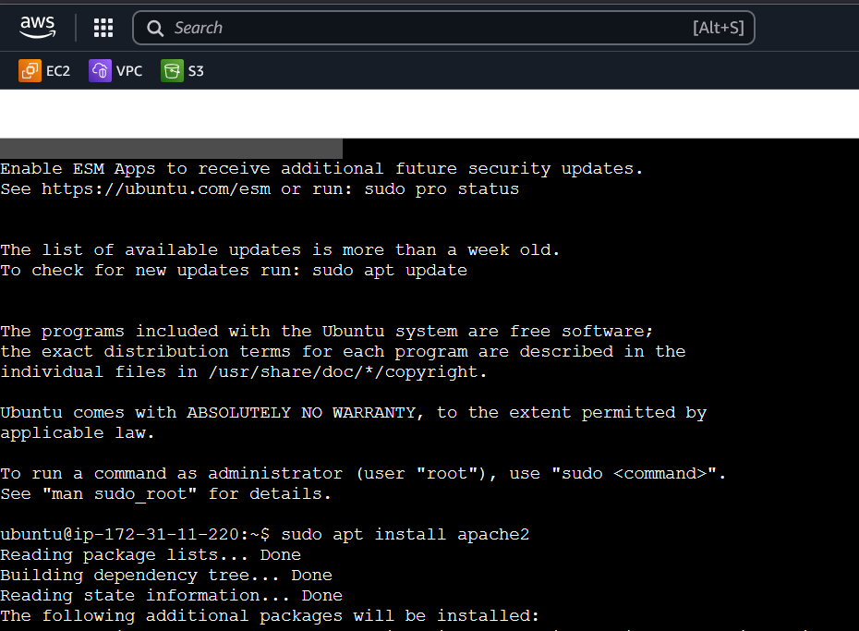

Create an EBS volume of 5 GB

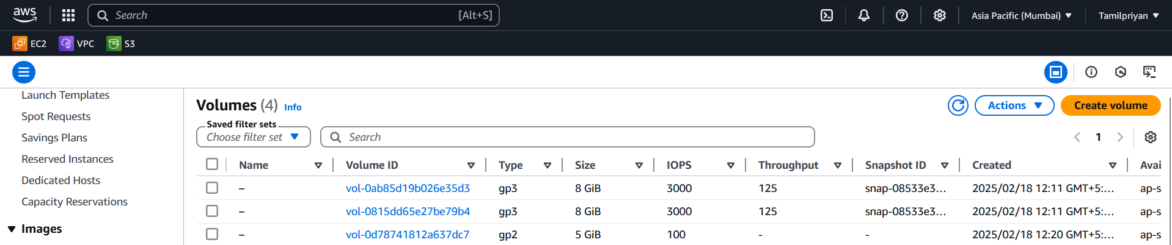

Attach it to an EC2 machine (Linux and Windows)

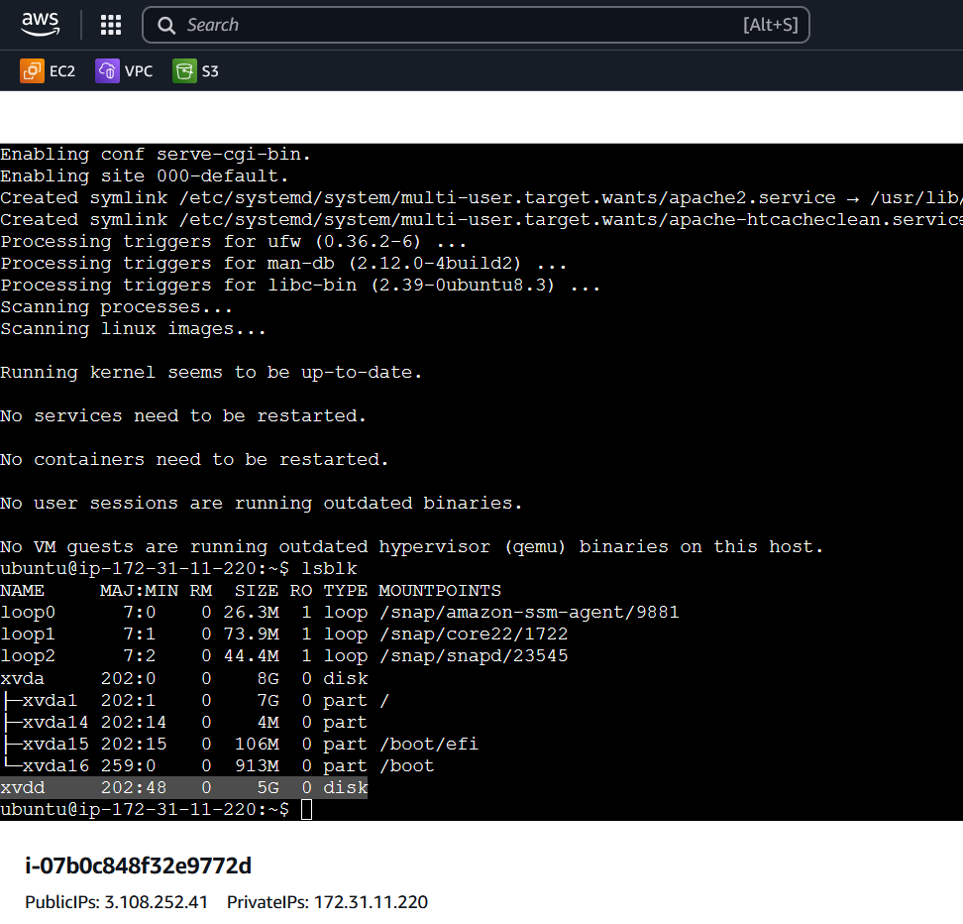

Take a snapshot

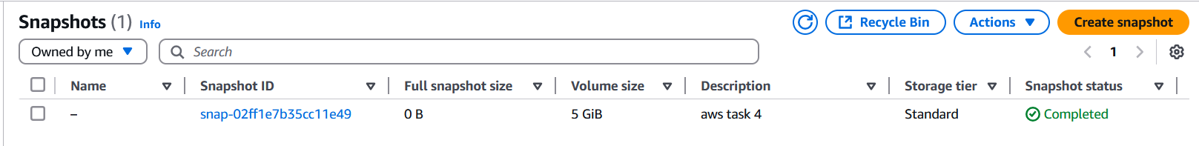

 Finally, create an EBS volume using the taken snapshot.

